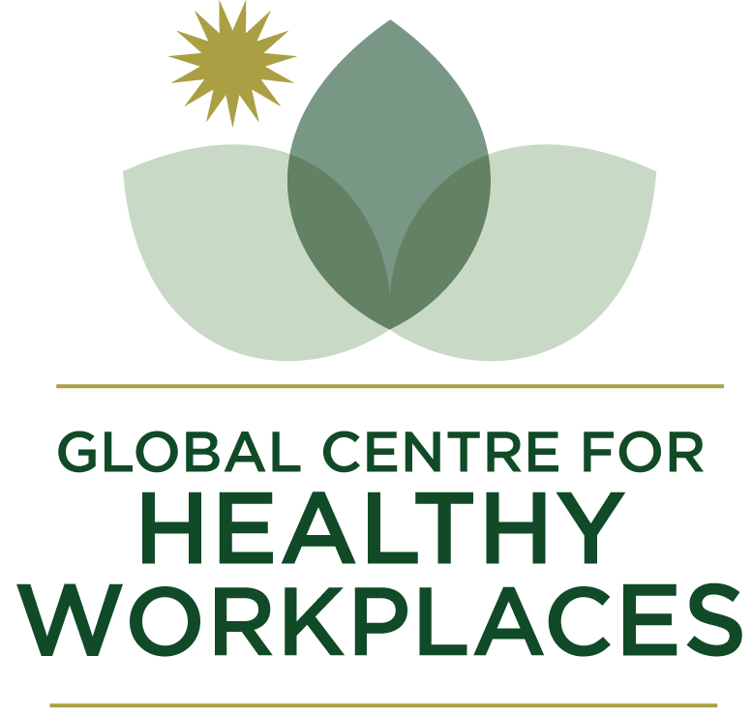

2026-27
Global Healthy Workplace Certification
Users Guide & Application Form

The Global Healthy Workplace Awards & Certification Programs are designed for organisations that excel in the creation of healthy workplaces. Both the Awards and Certification allow employers to compare and benchmark themselves to the global standard and, if successful, to celebrate their achievement as an employer-of-choice when seeking to attract new talent or retain existing employees. With an emphasis on both universal relevance and adaptability to local conditions, the programs demonstrate the employer‘s commitment to promoting a safe and healthy work environment and the health and wellbeing of its employees.
Applications for the Certification Program are open continuously throughout the year. It seeks to determine if the employer has reached a global standard in their designated category.
Employers who have received the Certification are automatically entered into the annual Awards program unless they have requested to opt out.
Please see the website for full details on the benefits and fees of the Certification program: https://www.globalhealthyworkplace.org/global-healthy-workplace-certification/

Certification Application
- Throughout the year applicants have the option to be assessed, and, if successful, certified as a “Healthy Workplace”.
Onsite Audit (optional)

Opting for the optional onsite audit and surpasses standard documentation reviews. Audit details are agreed in advance but physically involve inspecting facilities, the working environment, and daily practices to gain an in-depth understanding of your workplace’s strengths and commitment to employee wellbeing. This real-time engagement with staff will highlight your proactive healthy culture and operational excellence, positioning your organization for swift certification success, prestigious certification recognition and enhanced reputation. Audit details are agreed discussed upon acceptance of proposal.

Re-Certification

- Global Healthy Workplace certification Expires after two years. The renewal process involves updating data and policies rather than starting from zero. Renewal fee (20% off original fee) making it a cost-effective way to maintain a powerful, globally recognized quality mark.
- Benchmark against updated global standard.
Structured advisory session during the renewal cycle to review progress — what

Summary of options and fees

Certification by Policy & Documental Review (Option A) | Certification by Onsight Audit  (Option B)
Procedure  Submit application with payment.  Decision and expert feedback.  Successful applicants receive Certification in approx. 6-10 weeks. | Procedure  Submit application with payment.  Host onsite audit and receive instant feedback and expert dialogue.  Successful applicants receive Certification instantly.  To arrange onsite audit, contact info@globalhealthyworkplace.org
Fees  - Large Employer € 9,500  - Medium Sized Employer with 250-500 employees € 5,500  - Small Employer with less than 250 employees  € 950 | Fees  - Large Employer € 17,000  - Medium Sized Employer with 250-500 employees € 13,000
Payment by bank transfer or submit an invoice if preferred. All prices are in Euros and exclude VAT (where applicable).

Pathway to Certification (for early-stage programs)

Pathway to Certification is an entry-level option for r organizations with basic healthy workplace foundations but aren’t ready for full certification.

Key Features:

- Quick Assessment: A self-guided checklist covering core areas like policy basics, employee wellbeing, and safety essentials, without requiring extensive data analysis.
- Structured Mentoring: Includes two one-hour sessions with certified experts to pinpoint quick improvements and develop a customized roadmap.
- Branding Boost: Provides an “Emerging Healthy Workplace” label, shareable marketing materials, and a progress report for publicizing your efforts.
Pathway offers a smooth transition to the complete Global Healthy Workplace Certification. Participants can typically “graduate” within 6-12 months.

Fee: €1,500
2. To be eligible and for award consideration applicants must submit answers to all questions in the application and provide supporting documentation where indicated.
3. All questions are intended to address a unique and different program or organizational element. If you find your application repeating previous information you likely are not interpreting the question correctly. We are not asking for duplicate information anywhere in the application.
4. GCHW may need to ask certification applicants for additional information. Some applications may require modification and re-submission.
5. Applications which do not meet the certification criteria will receive a 50% refund and constructive feedback regarding deficiencies. Unsuccessful applicants may re-apply after six months. The full application fee must accompany any re-submissions.
6. Successful applicants will receive the Global Healthy Workplace Certificate along with display materials for premises and website.
6. Global Certificates are granted for 2-years and can be renewed. The renewal process requires an update from the original application with improvements and outcomes.
7. Certified organizations are automatically entered to the annual Global Healthy Workplace Awards Program (unless otherwise indicated in the application form). If Certification application is received by May 15, 2026 the entry will be in time for the 2026 Awards. Applications received after this date will be referred for entry to the 2027 Awards.
For more information on the Healthy Workplace Certification criteria and background go to http://www.globalhealthyworkplace.org/global-healthy-workplace-certification/
Global Centre for Healthy Workplaces retains all rights to the program.

Data Protection Statement
GCHW takes the protection of data extremely seriously. Information provided as part of an application for either an Award or Certification is shared only with the individuals assessing the application, namely the assessors, judges, and administrators. It is not under any circumstances circulated to third parties other than for the purpose of aggregated research where the identity of the data providers will not be published without their express permission in writing. Winners of Awards and certified applicants may be listed on the GCHW website and in newsletters, social media and press releases along with a brief high-level resume of their business drawn from information already in the public domain (for instance, from the applicant’s own website) or from content provided by the applicant for this purpose.
I/we consent to this statement

Global Healthy Workplace Certification Application

To ensure a complete understanding of what is required and the proper placement of information, it is recommended that you thoroughly review the entire application before answering the questions.

When completing the application please check the boxes if the criteria are met and use the text sections to elaborate and provide supporting documentation (where prompted).

Once completed, save the document as a PDF or word file and return with supporting evidence to info@globalhealthyworkplace.org

APPLICATION ADVICE AND GUIDANCE

The Certification criteria align closely with the WHO Healthy Workplace Model. It is recommended you read both the Healthy workplaces: a model for action (https://www.who.int/publications/i/item/healthy-workplaces-a-model-for-action) and the WHO healthy workplace framework and model (https://www.who.int/publications/i/item/who-healthy-workplace-framework-and-model) documents to give you a better understanding of what the GCHW is looking for in an application (both can be found at the following link):

Please ensure you answer all questions in full and with detail.

Awards Tutorial Video and Resources
Awards Tutorial Video: https://youtu.be/L3_hVPfdor4
Awards Guidance document: Download
Awards FAQs: https://www.globalhealthyworkplace.org/gchw-faqs/
Certification Overview Video: https://youtu.be/pr6-4duPejs

Our Awards & Certified Profiles, Case Studies, Research and Publications all have useful information about what makes a good healthy workplace.

Please note:
- The vast majority of information should be provided in the response box.
- Embed the supporting documents within the corresponding question in the application form, not external attachment (if possible)
- Videos are not accepted.
- A maximum of 2 photos are allowed.
- Please only submit your application in English.

If the overall application becomes too large size please send via Dropbox, Google Drive, WeTransfer or similar online cloud storage. Documents must be in English (or partially translated).

APPLICATION CONTENT

General Information………………………….…………….9

- Leadership Commitment and Engagement……………..10

- Worker Involvement………………………………………..12

- Business Ethics and Legality……………………………...13

- Programs and Policies……………………………………..15

- Continual Improvement and Systematic Process……….17

- Sustainability and Integration……………………………...20

General Information

- Full Name

- Position

- Email Address

- Organization’s Name and Address
(if the application relates to a subsidiary of a larger organization, please state the name of the parent company)

*applications for the Multinational Award category must pertain to all countries/divisions of the organization

- Number of employees

- Industry or Type of Business
Please provide a one-paragraph summary of your business (max. 50 words).

- Year in which the Healthy Workplace program began

- Is your application via one of our local Certification partner programs? If so, state the name of the partner

- Are you applying as an SME, Large or Multinational Employer?

! Important: Multinational employers must document how programs are linked to a global strategy and global standards or principles. It is necessary to provide examples of programs from various countries (including both developed and low income countries, if applicable) as well as of how the global strategy or policies are implemented on a local level. This should include data trends and potential program outcomes from different regions and countries.

- How did you hear about the Global Healthy Workplaces Awards and did you familiarize yourself with the WHO model?

To begin with please provide a brief summary paragraph of your Healthy Workplace program emphasizing the unique elements and clearly state your organization’s health and wellbeing goals (max. 250 words).

1. Organizational Commitment & Leadership Engagement

  - Has a Healthy Workplace strategic plan been signed off by the organization’s highest authority, which clearly indicates that healthy workplace initiatives are part of the organization’s business strategy and structure? Please explain.

  - Have employee representatives (e.g. works council, union, advisory committee) officially endorsed the Healthy Workplace strategy?

  - How does senior leadership actively promote opportunities for employee health and wellbeing as part of the organization’s core values?

Please provide examples/evidence of leadership support and participation.

  - How does middle management play an active role in advancing the strategy and programs? Is there a health and wellbeing component in the performance review of managers?

  - Has a health, safety and/or well-being policy or statement or health charter been developed and communicated throughout the organization?

For multinational organizations:
Does the policy / statement / charter apply globally?

Please submit a copy of the statement/charter
(one attachment max.).

  - Have the necessary resources been secured to plan, implement and evaluate the healthy workplace programs (i.e. personnel, technology, budget, responsible focal points)? Is there a dedicated budget for health and wellbeing?

  - Has a health & safety or wellbeing committee / group been established to oversee the process of creating a healthy workplace?

For multinational organizations:
Do you have a global committee and structure?

  - Does the committee/group represent different units / roles and diverse perspectives within the organization, e.g. management, workers, health, safety, HR, sustainability, diversity & inclusion?

Please provide evidence / details of your committee.

  - Does senior leadership regularly seek feedback from and contributes ideas to the health & safety or wellness committee? Please describe.

  - Are Healthy Workplace (health, safety, wellbeing) objectives and key performance indicators (KPIs) integrated into the corporate reporting system and explicitly featured in the annual report?

Please summarize below which KPIs and submit a link to the annual corporate report identifying the page number(s).

2. Worker Involvement
  - How are workers and their representatives actively involved in planning, implementing, and evaluating healthy workplace initiatives? Include feedback mechanisms and roles such as committees, surveys, wellbeing champions or ambassadors.

  - Do workers have collective means of expression, e.g. through trade unions, works councils, employee representatives, other committees?

  - Do workers receive official recognition for contributions to the planning / implementation of the program, e.g. in performance appraisals, awards, appreciation certificates?

  - What type of employee data do you gather to understand employee needs, preferences and satisfaction levels with the healthy workplace program?

  - What kind of participation does the Healthy Workplace program enjoy among the workers?

Please specify participation and satisfaction rates for offered activities. If possible, in all four Healthy Workplace areas: physical work environment, psychosocial work environment, personal health resources, enterprise-community involvement.

3. Business Ethics & Social Responsibility

  - Describe how the organization respects and protects the human rights and labor rights of its workers?

  - Describe how the organization enforces all relevant occupational health & safety codes/laws and abides by the ethical principle to “do no harm”?

  - Has the organization explicitly linked its Healthy Workplace program to the Sustainable Development Goals (SDGs)?

Please describe where this is stated in company policy and how it is implemented.

  - How does the organization promote and advance a diverse and inclusive workforce, e.g. policies, training, needs assessment, data tracking, employee resource groups?

Please provide examples/evidence of related policies or strategies.

  - How does the organization extend above specified rights and policies (3.1. to 3.4.) to its suppliers and contractors?

  - Does the organization report on ESG (Environment, Social, Governance)? If yes, what kind of health and wellbeing indicators are included in such report?

4. Programs and Policies

  - Do the programs and policies address health and safety concerns in the physical work environment?

Please provide examples/evidence, e.g. occupational health and safety management system.

  - Does the physical work environment reflect and support healthy building design, e.g. indoor air quality, lighting, noise, relaxation spaces, green spaces, opportunities for physical activity?

Please provide examples/evidence.

  - How do programs and policies address psychosocial dimensions and issues such as work design, work-life balance, work demands, work culture and employee growth and development?

Please provide examples/evidence, e.g. complying with psychosocial risk legislation, if applicable, or following a standard.

  - Do the programs and policies support employee wellbeing and healthy lifestyles? Do these programs / policies address different dimensions of wellbeing, e.g. physical, mental, emotional, social, financial, spiritual. Explain how.

Please provide examples/evidence.

  - What type of programs and policies exist to address and mitigate the effects of climate change, e.g. heat stress, pollution?

  - Are targeted programs offered for workers with specific needs, diseases (or at high risk for) and disabilities?

Please provide examples/evidence, e.g. for workers with chronic diseases, mental illness, musculo-skeletal disorders, return-to-work programs, modified or transitional jobs, for older workers.

  - Does the organization have a strategy and system in place to address future pandemics (e.g. safety practices, testing protocols, communication strategies, vaccination requirements, etc.)?

Please provide details / evidence about the plan.

  - Do the programs and policies support ways of participating in the community to improve the health of workers, their families and members of the community?

Please provide examples/evidence.

  - How do you ensure the offered programs and policies are utilized / adhered to by employees who may be primarily working remotely (outside of the office), e.g. risk assessments, ergonomics, work-life balance, health and safety in the home, financial support?

Please provide examples/evidence.

  - Explain how the programs offered are evidence-based and in line with established good practices.

Please specify the process how this is ensured.

5. Continual Improvement Process and Program Metrics / Outcomes
  - Have key health and safety issues and needs in the workplace been identified via required assessments of the environment and employees in relation to:
- physical & psychosocial work environment
- personal health resources and wellbeing status
- the broader impact of the organization on the health of the community?

Specify which assessments were conducted for each area.

  - Have priorities been developed based on assessed needs and communicated as part of a strategic plan?

Please provide examples of such priorities.

  - Has a comprehensive plan with specific actions been developed in consultation with a Healthy Workplace committee (or team) and external experts? Is the plan revised on annual basis?

  - Does the plan(s) include evaluation with measurable objectives?

Please provide examples/evidence of measurable objectives.

  - Are the programs conducted by professionals trained in the subject matter?

Please provide examples.

  - Has the effectiveness of the plan been evaluated?
Have the organization’s health and wellbeing goals been reached (to what degree)?
What kind of impact or outcomes (health and business-related) have been achieved?
Please state specific trends and improvements, either absolute or relational, e.g.

- program participation
- implementation of relevant policies
- satisfaction with programs
- employee health & wellbeing status
- health risks
- health behaviors
- employee engagement and morale
- workplace culture / climate
- sick leave statistics
- employee performance or productivity
- employee turnover
- employee satisfaction
- employees’ learning and growth to develop long-term success
- occupational injury or illness rates
- lost work time
- disability
- cost saving
- diversity & inclusion metrics
- other:

Please provide relevant data or trends over time for the metrics you checked (does not have to be for all of the listed metrics).
(3 attachments max.)

For multinational organizations: global, if available, and examples from different countries.

  - Have the findings and outcomes been documented and communicated to the organization’s leadership, middle management as well as to all employees?

  - How is feedback from various sources (internal and external) actively been sought to improve the program, including benchmarking (e.g. certification, audits, standards, benchmarking?

  - Have the plans been revised when circumstances indicate that the programs need improvement?

Please provide recent examples of this process.

6. Integration of Areas and Program Sustainability/Longevity

  - Have cross-functional teams been established to reduce isolation of work groups and ensure program and data integration, e.g. linking human resources, occupational health & safety, sustainability, diversity & inclusion, facility management?

Please provide examples of the integration of programs between units/departments.

  - What is the organization's strategy for ensuring long-term sustainability of the Healthy Workplace program?

Please provide evidence on how you are ensuring that the program will continue to be offered as part of the business strategy, e.g. during economic downturns, restructuring.

PLEASE REVIEW YOUR APPLICATION AND SUBMIT TO: info@globalhealthyworkplace.org

