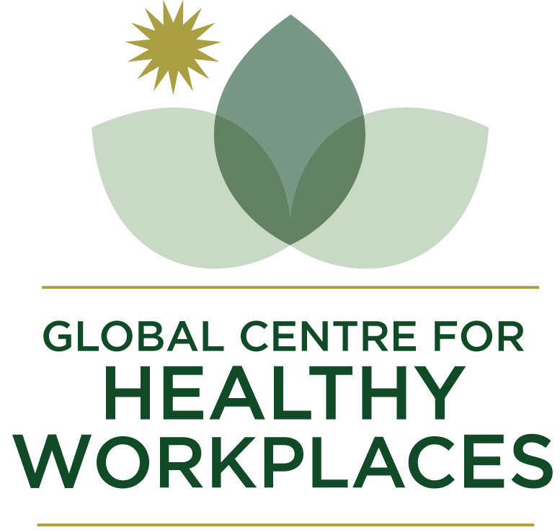

2022
Global Healthy Workplace Awards & Certification
Users Guide &
Application Form

The Global Healthy Workplace Awards & Certification Programs are designed for organisations that excel in the creation of healthy workplaces. Both the Awards and Certification allow employers to compare and benchmark themselves to the global standard and, if successful, to celebrate their achievement as an employer-of-choice when seeking to attract new talent or retain existing employees. With an emphasis on both universal relevance and adaptability to local conditions, the programs demonstrate the employer‘s commitment to promoting a safe and healthy work environment and the health of its employees.
The Application form for the Awards and Certification Program is the same.
Applications for the Awards program are open for a designated period each year (see www.globalhealthyworkplace.org/awards/application for dates). It seeks to determine the best employers in their designated category.
Applications for the Certification Program are open continuously throughout the year. It seeks to determine if the employer has reached a global standard in their designated category.
Any employer (whether certified or not) can apply for the Awards Program. Employers who have received the Certification are automatically entered into the annual Awards program unless they have requested to opt out.
There is no cost to enter the Global Healthy Workplace Awards, but a fee is charged for applicants who wish to have their program assessed under the Certification program. Please see the website for full details on the benefits of each program.
Awards: https://www.globalhealthyworkplace.org/awards/application/
Certification: https://www.globalhealthyworkplace.org/global-healthy-workplace-certification/
Awards Application
1. Submission timeframe for applications: Deadline: June 11, 2022
2. Applications are submitted in one of three categories:
a. Multinational organizations
b. Large organizations
c. Small and medium-sized organizations (up to 500 employees)
3. To be eligible and for award consideration applicants must submit answers to all questions in the application and provide supporting documentation where indicated.
4. Respond to the specific question and do not repeat information (e.g. general program descriptions).
5. Please be clear which supporting documents apply to which question.
6. Applications are assessed by a panel of five judges.
7. Two finalists per category will be invited to present their program at the forthcoming 9th Global Healthy Workplace Awards & Summit. One finalist from each category will be declared the Award winner at the Global Summit.
Certification Application
1. Throughout the year applicants have the option to be assessed, and, if successful, certified as a “Healthy Workplace”. The following fees are charged for this assessment:
- Large employer: US$ 4,750 p.a. (a second payment for the same amount is required in 12 months)
- Medium sized employer (with 250-500 employees): US$ 2,250 p.a. (a second payment for the same amount is required in 12 months)
- Small or micro employer (with less than 250 employees): US$ 475 (a second payment for the same amount is required in 12 months)
All prices include VAT.
2. Certifications are granted for local or national organizations / legal entities (multinational companies can apply with a country site or branch).
3. GCHW may need to ask certification applicants for additional information. Some applications may require modification and re-submission.
4. Applications which do not meeting the certification criteria will receive a 50% refund and constructive feedback regarding deficiencies. Unsuccessful applicants may re-apply after six months. The full application fee must accompany any re-submissions.
5. Successful applicants will receive the Global Healthy Workplace Certificate along with display materials for premises and website.
6. Global Certificates are granted for 2-years and can be renewed. The renewal process requires outcomes in relation to the original application to be documented.
7. Certified organizations are automatically entered to the annual Global Healthy Workplace Awards Program (unless otherwise indicated in the application form). If Certification application is received by June 11, 2022 the entry will be in time for the 2021 Awards. Applications received after this date will be referred for entry to the 2022 Awards.
For more information on the Healthy Workplace Certification criteria and background go to http://www.globalhealthyworkplace.org/global-healthy-workplace-certification/
Global Centre for Healthy Workplaces retains all rights to the program.
Data Protection
GCHW takes the protection of data extremely seriously. Information provided as part of an application for either an Award or Certification is shared only with the individuals assessing the application, namely the assessors, judges, and administrators. It is not under any circumstances circulated to third parties other than for the purpose of aggregated research where the identity of the data providers will not be published without their express permission in writing. Winners of Awards and certified applicants may be listed on the GCHW website and in newsletters, social media and press releases along with a brief high-level resume of their business drawn from information already in the public domain (for instance, from the applicant’s own website) or from content provided by the applicant for this purpose.
I/we consent to this statement

Global Healthy Workplace Awards & Certification Application

To ensure a complete understanding of what is required and the proper placement of information, it is recommended that you thoroughly review the entire application before answering the questions.

When completing the application please check the boxes if the criteria are met and use the text sections to elaborate and provide evidence (where prompted).

Once completed, save the document as a PDF or word file and return with supporting evidence to info@globalhealthyworkplace.org

Please tick/cross/delete where applicable. Are you applying for:

Awards ONLY
Certification ONLY (includes a fee for certification)
BOTH (includes a fee for certification)

Certification Payment

Please submit Certification payment by PayPal via the button on the GCHW website:
http://www.globalhealthyworkplace.org/global-healthy-workplace-certification/

If you wish to make payment via bank transfer, we can send you an invoice with the necessary details. Please let us know via email to info@globalhealthyworkplace.org.

**Full Payment must be received prior to the submission of the application.

All prices include VAT.

APPLICATION ADVICE AND GUIDANCE

The Awards and Certification criteria align closely with the WHO Healthy Workplace Model. It is recommended you read both the Five Keys to Healthy Workplaces flyer and Introducing healthy workplaces: a model for action documents to give you a better understanding of what the GCHW is looking for in an application (both can be found at the following link): http://www.who.int/occupational_health/healthy_workplaces/en/

Please ensure you answer all questions in full and with detail.

Awards Tutorial Video and Resources
Awards Tutorial Video: https://youtu.be/L3_hVPfdor4
Awards Guidance document: Download
Awards FAQs: https://www.globalhealthyworkplace.org/gchw-faqs/
Certification Overview Video: https://youtu.be/pr6-4duPejs

Our Awards & Certified Profiles, Case Studies, Research and Publications all have useful information about what makes a good healthy workplace.

Supporting Documents

The supporting documents you provide must be clearly numbered/named and referenced to within the related question on your application form. PDF, word, xls, ppt, jpg and png are all accepted file formats. Documents must be in English (or partially translated).

If your supporting documents are large in size (> 10 MB), please do not send in separate emails. Instead, send us a link to the files via Dropbox, Google Drive, WeTransfer or similar online cloud storage.

Please note:
- Videos are not accepted.
- If submitting photos, you can only submit a maximum of 5.
- Make sure you provide supporting documentation where prompted.
- Please only submit your application in English.

APPLICATION CONTENT

General Information………………………….…………….7

Leadership Commitment and Engagement……………..7

Worker Involvement………………………………………..9

Business Ethics and Legality……………………………..10

Programs and Policies…………………………………….11

Continual Improvement and Systematic Process……..12

Sustainability and Integration……………………………14

General Information

- Full Name

- Position

- Email Address

- Organization’s Name and Address
(if the application relates to a subsidiary of a larger organization, please state the name of the parent company)
*applications for the Multinational Award category must pertain to all countries/divisions of the organization

- Number of employees

- Industry or Type of Business
Please provide a one-paragraph summary of your business (max. 50 words).

- Year in which the Healthy Workplace program began

- Is your application via one of our local Certification partner programs? If so, state the name of the partner

- Are you applying as an SME, Large or Multinational Employer?

Important: Multinational employers must document how programs are linked to a global strategy and global standards or principles. It is suggested to provide examples of programs from various countries as well as of how the global strategy or policies are implemented on a local level. This should include data trends and potential program outcomes from different regions and countries.

- How did you hear about the Global Healthy Workplaces Awards and did you familiarize yourself with the WHO model?

To begin with please provide a brief summary paragraph of your Healthy Workplace program emphasizing the unique elements (max. 250 words).

1. Organizational Commitment & Leadership Engagement

  - Has a Healthy Workplace strategic plan been signed off by the organization’s highest authority, which clearly indicates that healthy workplace initiatives are part of the organization’s business strategy? Please explain.

  - Have employee representatives (e.g. works council, union, advisory committee) officially endorsed the Healthy Workplace strategy?

  - Does the senior leadership actively promote opportunities for employee health as part of the organization’s core values and participate in programs?

Please provide examples/evidence of leadership support.

  - How does middle management play an active role in advancing the strategy and programs? Is there a health and wellbeing component in the performance review of managers?

  - Has a health, safety and/or well-being policy or statement or health charter been developed and communicated throughout the organization?

Please submit a copy of the statement/charter.

  - Have the necessary resources been secured to plan, implement and evaluate the healthy workplace programs (i.e. personnel, technology, budget, responsible focal points)?

  - Has a health & safety or wellness committee / group been established to oversee the process of creating a healthy workplace?

  - Does the committee/group represent different units / roles and diverse perspectives within the organization, e.g. management, workers, health, safety, sustainability, diversity & inclusion?

Please provide evidence / details of your committee.

  - Does senior leadership regularly seek feedback from and contributes ideas to the health & safety or wellness committee

  - Are Healthy Workplace (health, safety, wellbeing) objectives and key performance indicators (KPIs) integrated into the corporate reporting system and explicitly featured in the annual report?

Please submit a link to the corporate report identifying the relevant KPIs or summarize below.

2. Worker Involvement
  - Are workers and their representatives actively involved in the process from planning to evaluation considering their opinions and ideas, e.g. via committees, surveys, wellness champions/ambassadors, employee resource groups?

  - Do workers have collective means of expression, e.g. through trade unions, employee representatives, other committees?

  - Do workers receive official recognition for contributions to the planning / implementation of the program, e.g. in performance appraisals, awards, appreciation certificates?

  - Does the Healthy Workplace program enjoy broad participation among the workers?

Please specify participation and satisfaction rates for offered activities with regard to the four Healthy Workplace areas: physical work environment, psychosocial work environment, personal health resources, enterprise-community involvement.

3. Business Ethics & Social Responsibility

  - Does the organization respect and protect the human rights and labor rights of its workers?

  - Does the organization enforce all relevant occupational health & safety codes/laws and abide by the ethical principle to “do no harm”?

  - Has the organization explicitly linked its Healthy Workplace program to the Sustainable Development Goals (SDGs)?

Please describe the link and how/where this is stated in company policy and implemented.

  - Does the organization promote and advance a diverse and inclusive workforce, e.g. policies, training, needs assessment, data tracking, employee resource groups?

Please provide examples/evidence of related policies or strategies.

4. Programs and Policies

  - Do the programs and policies address health and safety concerns in the physical work environment?

Please provide examples/evidence, e.g. occupational health and safety management system.

  - Does the physical work environment support healthy building design, e.g. indoor air quality, lighting, noise, relaxation spaces, opportunities for physical activity?

Please provide examples/evidence.

  - Do the programs and policies address health and wellbeing concerns in the psychosocial work environment including work design, work-life balance, work demands, work culture and employee growth and development?

Please provide examples/evidence, e.g. complying with psychosocial risk legislation.

  - Do the programs and policies support employee wellbeing and healthy lifestyles? Explain how.

Please provide examples/evidence.

  - Are targeted programs offered for workers with specific diseases (or at high risk for) and disabilities?

Please provide examples/evidence, e.g. for workers with chronic diseases, mental illness, musculo-skeletal disorders, return-to-work programs, modified or transitional jobs.

  - Do the programs and policies support ways of participating in the community to improve the health of workers, their families and members of the community?

Please provide examples/evidence.

  - How do you ensure the offered programs and policies are utilized / adhered to by employees who may be primarily working from home (outside of the office), e.g. risk assessments, ergonomics, work-life balance, health and safety in the home, financial support)?

Please provide examples/evidence.

  - Explain how the programs offered are evidence-based and in line with established good practices.

Please specify the process how this is ensured.

5. Continual Improvement and Systematic Process
  - Have key health and safety issues and needs in the workplace been identified via required assessments of the environment and employees in relation to:
- physical work environment
- psychosocial work environment
- personal health resources and status
- the broader impact of the organization on the community?

Specify which assessments were conducted for each area.

  - Have priorities been developed based on assessed needs and communicated as part of a strategic plan?

  - Has a comprehensive plan with specific actions been developed in consultation with a Healthy Workplace committee (or team) and external experts?

  - Does the plan(s) include evaluation with measurable objectives?

Please provide examples/evidence of measurable objectives.

  - Are the programs conducted by professionals trained in the subject matter?

  - Has the effectiveness of the plan been evaluated? What kind of impact or outcomes (health and business-related) have been achieved? Please state specific improvements, either absolute or relational, e.g.

- program participation
- implementation of relevant policies
- satisfaction with programs
- employee health & wellbeing status
- health risks
- health behaviors
- employee engagement and morale
- workplace culture / climate
- sick leave statistics
- employee performance or productivity
- employee turnover
- employee satisfaction
- employees’ learning and growth to develop long-term success
- occupational injury or illness rates
- lost work time
- disability
- cost saving
- diversity, equity & inclusion
- other:

Please provide relevant data or trends for the metrics you checked.

  - Have the findings and outcomes been documented and communicated to the organization’s leadership, middle management as well as to all employees?

  - How is feedback from various sources (internal and external) actively been sought to improve the program, including benchmarking?

  - Have the plans been revised when circumstances indicate that the programs need improvement?

Please provide examples of this process.

6. Integration and Program Sustainability/Longevity

  - Have cross-functional teams been established to reduce isolation of work groups and ensure data integration, e.g. linking human resources, occupational health & safety, sustainability, diversity & inclusion, facility management.?

  - Does the program have a plan for continued operation and ongoing improvements?

Please provide evidence on how you are ensuring that the Healthy Workplace program will continue to be offered as part of the business strategy?

Awards Deadline: June 11, 2022

PLEASE REVIEW YOUR APPLICATION AND SUBMIT TO: info@globalhealthyworkplace.org

